**Week-1 Assignment: LAB-1**

1. Network Connectivity

Verify that the Network Configuration for all VM's is set to NAT. The following tasks then expand upon this to ensure your VM's can communicate with each other on the same network using some of the basic, built-in utilities to computer operating systems.

1. Document IP address, subnet, and gateway of system. Write the command to perform the operation.

Ans: 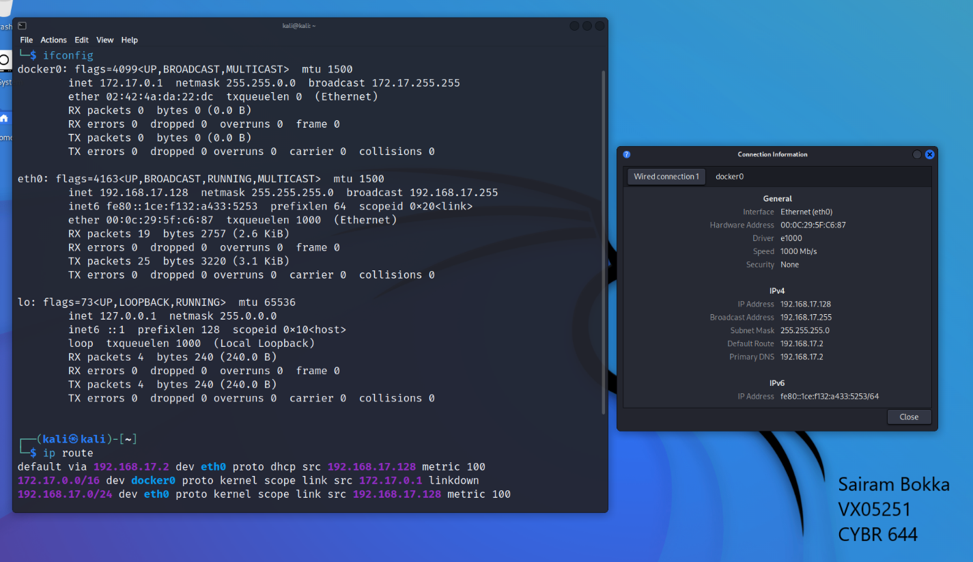

To find out the ipaddress, subnet and gateway of the windows machine, I used ipconfig command in powershell. This command displayed IPv4, IPv6, Subnet Mask and Default Gateway of the system.

For Kali, I used Ifconfig command in terminal which displayed IPv4 as inet, IPv6 as inet6, and netmask. To get the default gateway, I used ip route command as shown above.

1. How many potential hosts could be available on that same network?

Ans: The default subnet mask of 255.255.255.0 provides 256 total addresses, but two of those addresses are reserved for network and broadcast addresses, leaving only 254 addresses for hosts.

1. Find other hosts. Write the tool to find the other hosts.

To find out the number of hosts on my network, I used Nmap tool installed in the Kali Linux system. I ran Nmap -sn 192.168.17.128/24 where -sn is the type of scan, which means a ping scan. By default, Nmap performs port scanning, but this scan will disable port scanning.

1. Using the OS ping utility, try pinging random addresses to see if you can find another host online.

To ping various hosts, I used ping tool on kali linux. I pinged Windows 7 virtual machine and my windows 11 machine on kali linux.

1. Using the OS ping utility, ping google.com and umbc.edu.

1. What services are in use on your local system?

I used netstat to find all the services used in the system. Currently all the services are using TCP or UDP in my system.

1. What ports are listed and what is connected to the system? List the ports:

To find the ports connected to my kali system, I used netstat -antup command.

* The key options here are:
  + -a - Show all connections and listening ports
  + -n - Show numerical addresses instead of trying to resolve hostnames
  + -t - Show TCP connections
  + -u - Show UDP connections
  + -p - Show the process ID and name that opened each connection

3 tcp ports are in listen state and 1 udp port has connection established to kali system.

1. Launch a browser and go to google.com and repeat #7?

Multiple TCP connections were established after launching google.com on firefox browser in my kali linux system.

2. Routing

1. What route/ARP information does your system have?

I used arp -a command on my windows 7 machine to generate arp data on powershell.

1. What “extra” information do you know about the system in #3?

Ans: Apart from IP addresses of the system, we can find the MAC addresses of the system connected to this subnet as shown in the above ARP data.

1. Trace a route to an internal IP that responded in the previous section.

The route can be traced in kali linux using traceroute command in terminal.

1. Trace a route to an external IP that responded in the previous section, such as umbc.edu's IP?

The route to umbc.edu can be traced using traceroute umbc.edu